Assignment 1 Critique

1. Older Visualization:

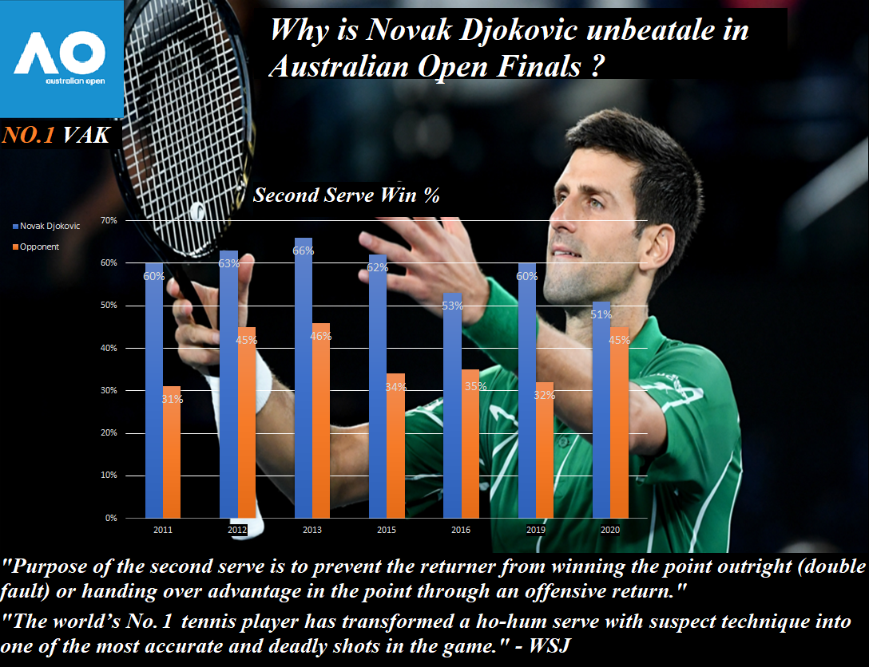

1. Strengths:
   1. The Australian Open Logo on the top-left side emphasises that this visualization is only about AO.
   2. The picture of Novak Djokovic in the background helps the reader to connect the name and the face of the player the visualization is talking about.
   3. Color scheme used is pleasing and directs the readers focus at the chart because of the bright colors standing out over the dark black background.
   4. The exact value for each bar is written in numerical form on the bar itself. This makes it easier for reader to access the information.
   5. The importance of the second serve win% is given below the chart so that reader can understand why this category was selected.
   6. The No. 1 VAK label on the left side below the AO logo reminds the readers that Novak Djokovic is the world’s No 1 tennis player.
2. Weaknesses:
   1. Add a “Did you know” section in the end and explain the importance of Second Serve Win %. Remove all other text which is not required.
   2. The font size of the legend and the textual labels are too small.
3. New Vizualization

